Dear Meadowers,

Our values are Be Kind, Be Safe and Be Responsible. This week's article from The Children's Charter is article 28.

Article 28 of the CRC says that all children across the world have the right to access primary education for free, and secondary education must be available to every child. It also speaks of the importance of children being treated with dignity in their school setting.

It's always amazing how short weeks always seem so much longer than the 5 day ones!!!
This week all teaching staff have been taking part in their Professional Review and Development meeting. This is where they review their professional learning and set targets for the future. It's always a great pleasure to have these conversations as we have a very committed team of teachers who are always looking to improve.

Next week we have Parents Night, and we are trialling having one in person and one online. We will send out an evaluation afterwards to see if this has worked. If you have opted for the online one on Wednesday but want to visit the classroom you are more than welcome to pop in on the Thursday. We do have a book fair but please can I stress you do not have to buy any books. We fully appreciate that things are very tough at the moment and would hate for anyone to feel they were under pressure to buy anything.

On Friday 16th 100 pupils and staff went to the Emirates to watch the Davis Cup. The children were amazing and even got a standing ovation from the rest of the audience as well as the players for their enthusiasm and behaviour. We are very proud of them and it was fantastic to see the tweets online about them.

Our P7s this week have been involved in a World War 2 walk around the area. P4 have had a visit to the tennis club.

Our Jeans for Genes day raised £383.37 which was a fantastic response but more importantly we were able to share about what Jeans for Genes is all about. Next week on 6th October we are encouraging the children and staff to wear something green to show support and awareness for World Cerebral Palsy. This has come as a request from one of our infant children.

Some of the staff took part in Challenge 60 which meant we walked 60 miles during September to raise money for Childhood Cancer Awareness. We managed to raise over £2000 for this charity which supports one of our P2 children.

We are signed up for the Rights Respecting School Award and our Learning Committee will be sharing more about this in due course. Here is the link to what this is all about. One aspect of the award is making sure you are aware that we are doing this.
https://www.unicef.org.uk/rights-respecting-schools/

We also are working towards the Reading Schools Award. Again, have a look at their website if you would like to find out more. We have a Library Committee (known as our Book Worms) who are doing a great job sorting out our library and encouraging us to read for pleasure. https://www.scottishbooktrust.com/learning-and-resources/reading-schools
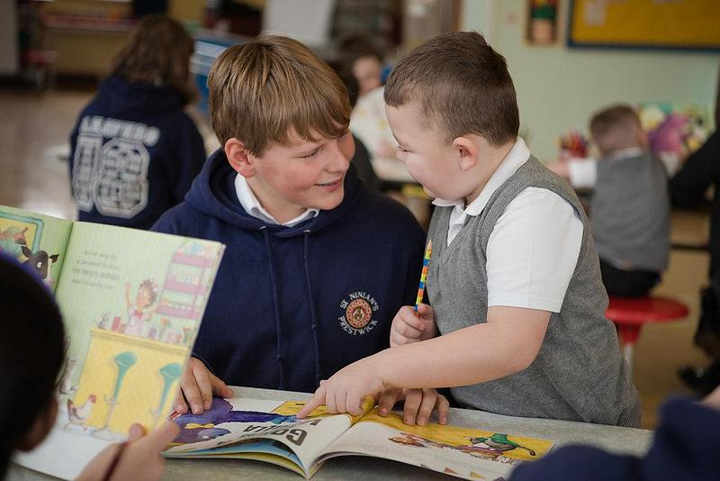 | Reading Schools - Scottish Book Trust  Reading Schools is open to every school in Scotland! About Reading Schools. Reading Schools is an accreditation programme for schools that are committed to building a culture of reading for their learners and communities.  www.scottishbooktrust.com

A little reminder that whilst we have water fountains at school it is a good idea for every child to have their own water bottle which they can fill up and use. School can be thirsty work and we need to keep hydrated if we want to do our best.

Miss Roddick has currently been organising some modern languages after-school clubs and Mrs Gordon is working with Active Schools trying to organise as many active opportunities as she can. Remember if you have a skill and could offer an opportunity for our children then please do get in touch.

Bikeability has begun for P7 children and they will be out and about on the roads shortly.

We have a new chair for the Parent Council. Lyndsey Saunders is taking over from Jennifer Jamieson. Lyndsey has children in P4 and P1. We are so grateful for all Jennifer has done for the school over the last few years particularly during Covid times. Lyndsay can be contacted through the Parent Council email address lenziemeadowprimarypc@gmail.com. Please remember if you have a comment or concern about a personal issue to do with an individual child this should come through the school office so we can help and not through Parent Council.

We also have new Parent Council Reps for each year group. These can be found on the minutes of the Parent Council meeting on the school website. Again, another big thank you to the parents who have served on this group for the last couple of years. We appreciate the time, support and discussions we have enjoyed.

Today your child will have come home with a book about Queen Elizabeth 2. If you do not wish this book, please just return to school. We applied for these at the time of the Jubilee and they arrived with us this week.

That's all for this week!!! have a great weekend.
Sheona

